The Winns Library Project
The Winns Primary School has a Brand-New Library!
During the Easter holidays, Winns Primary School staff and the school’s Parent/Teacher association (Friends of The Winns aka “FOTW”) have been hard at work delivering the first phase of the transformation of the school library, from an old-fashioned, uninspiring space to a bright, engaging and invigorating space that invites children to discover and be immersed in books.
We are lucky to have a library at The Winns. 1 in 7 primary schools in England do not have a dedicated library and nearly 1m children in the UK do not have access to books. We recognise that children who attend The Winns are fortunate to have ready access to a well stocked library, and a space to enjoy reading, researching, discovering, and relaxing. However, the library’s physical space was bland and tired, and the book collection had not been kept up to date.
The suggestion to refurbish the library was proposed in a FOTW meeting at the end of September 2022. The library had been a place of joy and sanctuary for a very special student, Oscar Nichols, who was a pupil at The Winns until July 2021. Sadly, Oscar passed away in 2022, after a long period of illness. Oscar was much loved by everyone at The Winns. His spirit, his sense of humour and his incredible zest for life, even when things were hard, meant that he was cherished by everyone who was lucky enough to know him. He taught us all so much about care, compassion, resilience and the desire to enjoy every precious moment in life. Oscar and his friends loved the Winns library and spent many happy times together there. The idea to refresh the library into a space all children can enjoy with their friends and find joy in books felt like a very fitting legacy to honour Oscar.
Key skills within the parent community were identified, resulting in an enthusiastic group of volunteers coming together to form a project team. The team then worked closely with the school to understand the improvements required in the library. Many of the core design principles were based on feedback from the school council (a representative group of the student body), who completed a survey asking them what changes they would like to see in the library. The senior staff of the school also shared their vision, making it clear that they wanted the library to be at the very heart of the school community.
All this information was compiled and used to create the ambitious new design. Due to the scale of the changes required and the budget available, the project was split into two phases, of which Phase One has been delivered ready for the start of the summer term.
The project has been run over the last six months by a multi-talented team of parents that included artists, librarians, authors, architects, designers, project managers, inclusive design experts, publishers, enthusiasts and supporters. Phase One of the project has delivered a new look for the library which incorporates accessible design principles to ensure the space is appropriate for all ages from nursery to year 6 and is easily navigable for children with different needs. This work was made possible by FOTW fundraising, including generous donations from a month-long Readathon in March and a book fair.
The new library has a feature wall with a fantastic rainforest mural, new soft furniture, a new carpet, hand drawn window illustrations and bespoke cladding transforming the existing bookshelves (which were re-sprayed to better fit the new colour scheme). The school’s core values (“Belong”, “Grow”, “Explore” and “Achieve”) have been included in the graphic illustrations, underlining the ethos and culture at the Winns.
A specially commissioned sculpture of The BFG sculpture will also take pride of place in the library. Oscar particularly loved the story of The BFG, and we look forward to his friends and all children enjoying stories sitting alongside the BFG.
In addition to transformation of the physical space, the book collection has also been overhauled. Teachers and parent volunteers have worked hard to curate and modernise the book collection, weeding out old, irrelevant and (in some instances) physically decaying titles. The school staff also created a “library wishlist”, of new and inclusive books which better represent the needs of the children and our diverse community. Via the “library wishlist”, parents, carers and supporters were able to directly purchase new books for the school from an independent bookseller.
And just like that, during the Easter holidays the transformation has been completed and will be unveiled to pupils this week, the first week of the summer term. The children can’t wait to get back into their new-look library, and the work of refreshing the book collection will continue as an ongoing task over the coming months.
The project team’s primary focus will now shift to applying for grants to fund phase two, which is due to deliver ambitious bespoke shelving and seating, a cosy nook dedicated to Oscar and create a fully immersive space that celebrates the joy of books and stories.
Thanks to everyone who has supported this ongoing project with time, ideas, skills and donations. If you have been inspired by our story and would like to support this cause or add to the magic in Phase Two, please contact fotwchair@gmail.com

“We are absolutely delighted with our newly refurbished library. The space has been transformed into a beautiful room that will be enjoyed by our children for years to come. Developing a love for reading is a huge priority for us at The Winns. Having this magical space will really help us to make sure that our children discover the joy of reading and develop a real passion for books.

We are hugely grateful to our parent group who have done an incredible job working together to make this happen . Your hard work, determination and commitment to our school is hugely appreciated.”
Fiona Judge, Head Teacher
“Oscar loved being part of Winns Primary and spent a lot odf time in the library, so we are really proud that his memory will live on as part of the library refurbishment, He was a great lover of nature so would definitely have approved of the theme. We are grateful to the school and the parent’ project team for all their hard work.” - Oscar’s family

“Best library in the world” Student
“This will really encourage the younger kids to read” Year 6 student
“Can you do another one but in my house” Student
“I cant believe all our ideas were listened to” School Council student member
“I don’t like it, I LOVE it” Year 1 student

Belong, Explore, Grow Achieve
-END -

Written By Marlene Service ( Winns Parent)

Before pictures:
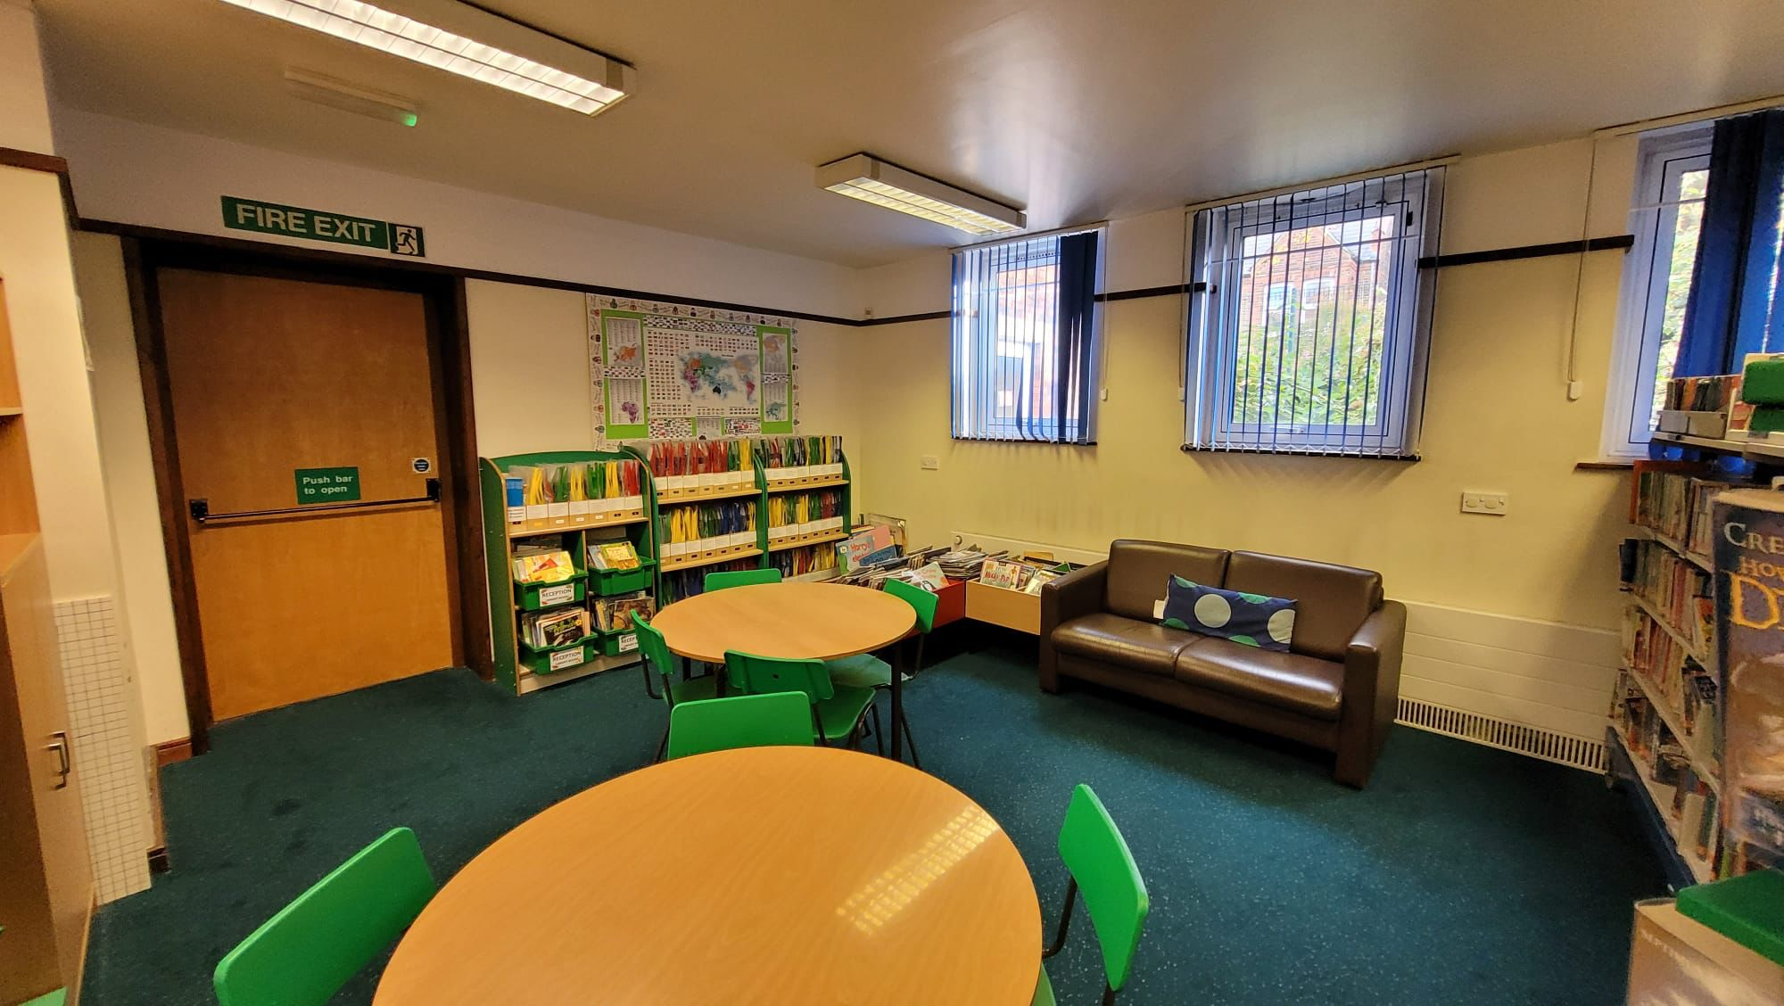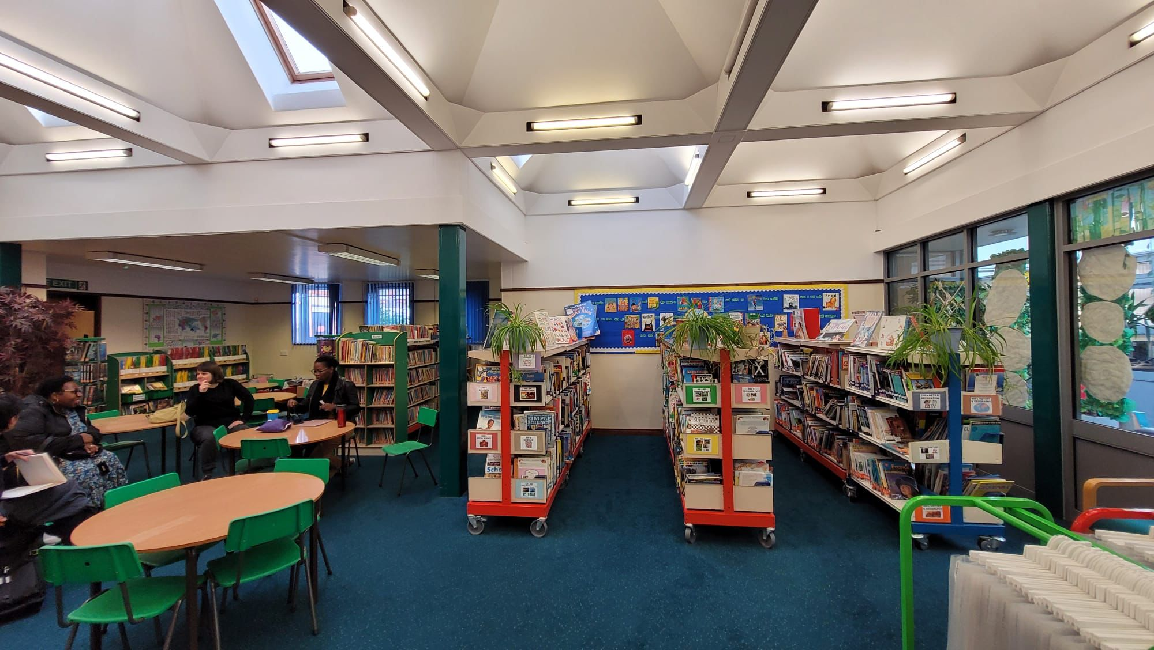

During pictures:
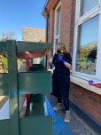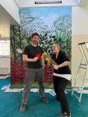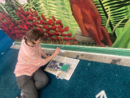

After pictures
